Parabola: a U-shaped curve.
- All quadratic functions form parabolas.

Standard Form of a Quadratic: ${ax}^{2}+bx+c$
- ${ax}^{2}$ is the quadratic term.
- $bx$ is the linear term.
- $c$ is the constant term.

Intercepts | X-intercepts: the x-coordinates of the points where the graph intersects the x-axis.  - X-intercepts can be found by factoring and solving the equation for x.  - Not all quadratic functions have x-intercepts.  Y-intercept: the y-coordinate of the point where the graph intersects the y-axis. All quadratic functions have exactly 1 y-intercept.  - In standard form, $c$ is the y-intercept.
The Discriminant | The discriminant helps us know whether a function has x-intercepts.  - Discriminant formula: $b^{2}-4ac$  - If it’s negative, there are no x-intercepts.
The graph of $y=x^{2}-2x-4$ is shown below.
- The y-intercept is $c$, or -4.

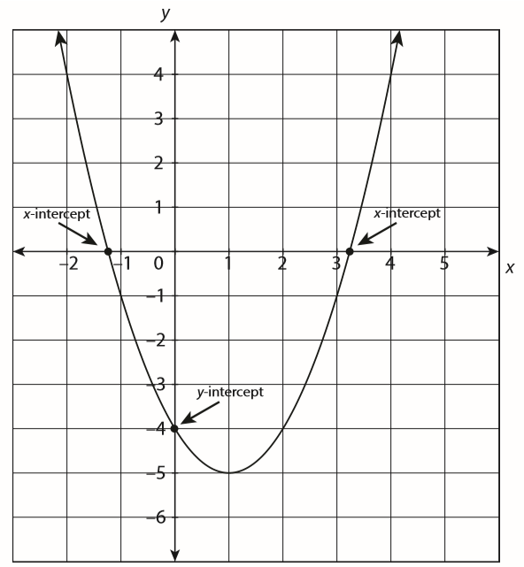
Vertex and Axis of Symmetry | The vertex of a parabola is the point where the graph changes direction.  The axis of symmetry is the line through the vertex of a parabola. The parabola is symmetric about this line.  - Axis of symmetry formula: $x=\frac{-b}{2a}$  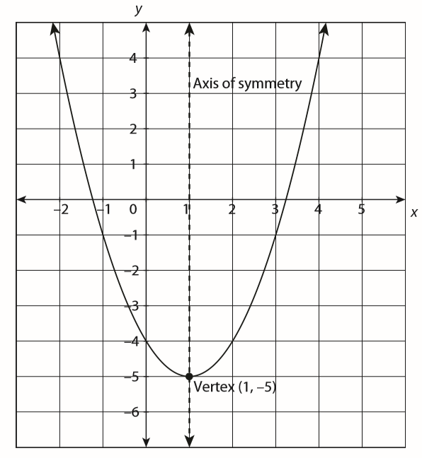  In the graph above, the equation of the axis of symmetry is $x=1$ because the vertical line through 1 is the line that cuts the parabola in half.
The vertex always lies on the axis of symmetry.

To find the vertex from the equation,
- Use the formula $x=\frac{-b}{2a}$ to find the x-coordinate.
- Substitute that number into the equation for x and solve for y to find the y-coordinate.
Maximum and Minimum | The y-coordinate of the vertex is the maximum or minimum value.  - Maximum: the greatest y-value of a function  - Minimum: the least y-value of a function  In standard form, you can tell whether a function has a maximum or minimum by the sign of $a.$  - If $a>0$, the parabola opens up and has a minimum value.  - If $a<0$, the parabola opens down and has a maximum value.  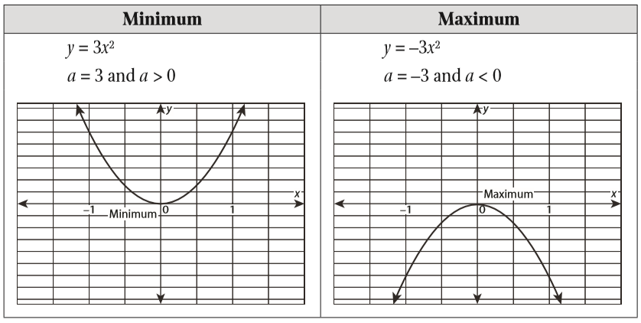
Guided Practice | - Find the y-intercept and vertex of the function $y=-2x^{2}+4x+3$. Determine whether the vertex is a minimum or maximum point on the graph.
 | - $y=2x^{2}-11x+5$ is a quadratic function. Determine the direction in which the function opens, the coordinates of the vertex, the axis of symmetry, the x-intercepts (if any), and the y-intercept.
 | - $y=2x^{2}+8x+8$ is a quadratic function. Determine the direction in which the function opens, the coordinates of the vertex, the axis of symmetry, the x-intercepts (if any), and the y-intercept.
 | - $y=-x^{2}+8x-17$ is a quadratic function. Determine the direction in which the function opens, the coordinates of the vertex, the axis of symmetry, the x-intercepts (if any), and the y-intercept.

